PROJECT REPORT · AI-ML AND GENAI TRACK
PocketSmart
AI
Your smart budget and recommendation assistant

BUILT WITH  FastAPI · Gemini · SQLite | PLANNERS  Home · Party · Jewelry | STORES  Amazon · Flipkart · IKEA  Swiggy · Zomato · OYO

Submitted by
Sunmathi
Menaka Shree
Shabna I
Vithyasri Viswanathan

Theeran Chinnamalai College of Arts and Science for Women
BSc Computer Science (AI), affiliated to Bharathiar University
Date: 29/09/2026

Contents

01 | At a Glance | The problem, the idea and what the app does
02 | Three Planners | Home interior, party and jewelry scenarios
03 | System Design | Architecture, request flow, database and user journey
04 | Build Journey | Five milestones from API key to working app
05 | Testing & Quality | Test cases, quality checks and the fallback
06 | Limits & Next Steps | What it cannot do yet and where it can go
07 | Conclusion | Summary and how to run the project

01 | At a Glance  Why PocketSmart AI exists and what it does

The problem
Someone furnishing a room, hosting a party or choosing jewelry faces too many products, platforms and price points. Prices differ from store to store, and nothing splits one budget sensibly across everything that has to be bought. People overspend, or lose hours comparing tabs.
The idea
PocketSmart AI takes a single budget and a few preferences, asks Google's Gemini model for a plan, and returns a structured list. Every item has an estimated price, a one-line reason and a link that opens a search on the right store. The whole plan is saved to the user's history.
3  planners | 6  store platforms | 2  database tables | 13  test cases

Who it is for
■ Students and young professionals furnishing a first home
■ Families organising birthdays, weddings and get-togethers
■ Shoppers choosing jewelry that matches an outfit and an occasion
Ideas considered
Idea | Decision | Reason
One generic budget chatbot | Rejected | Answers were vague and unstructured
Separate planners with tailored forms | Chosen | Each domain collects the details it needs
Live scraping of shopping sites | Rejected | Sites block scraping and terms forbid it, so search links are used
Image input for jewelry | Chosen | Outfit colours make matches more accurate

KEY DESIGN DECISION
The app never scrapes stores or invents product URLs. Gemini suggests items and prices, and the application builds each store link itself, so a link always opens a real search page.

02 | Three Planners  The scenarios the application is built around

SCENARIO 1 · SMART BUDGET ALLOCATION
Home Interior Planner
The user picks rooms such as the Living Room and Kitchen, and the number of lights, ceiling fans and dining tables. Gemini balances function, style and price and recommends an item for each need, so the room is furnished without overspending.
You enter: budget, rooms, lights, fans, dining tables, style
Stores used: Amazon, Flipkart, IKEA

SCENARIO 2 · AI-BASED PARTY BUDGET
Party Planner
The user gives a total budget, guest count, event type and venue. The AI divides the money across catering, decoration, entertainment and venue or stay. Catering is shown with a cost per guest, and picks change with the event type.
You enter: budget, guests, event type (birthday, corporate, wedding, get-together), venue
Stores used: Swiggy, Zomato, OYO, Amazon

SCENARIO 3 · OCCASION-BASED PICKS
Jewelry Planner
The user chooses an occasion and a style and can upload a photo of the outfit. Gemini reads the photo along with the text and coordinates colours, so the necklace, earrings and other pieces suit both the outfit and the budget.
You enter: budget, occasion, style, optional outfit photo (under 4 MB)
Stores used: Amazon, Flipkart

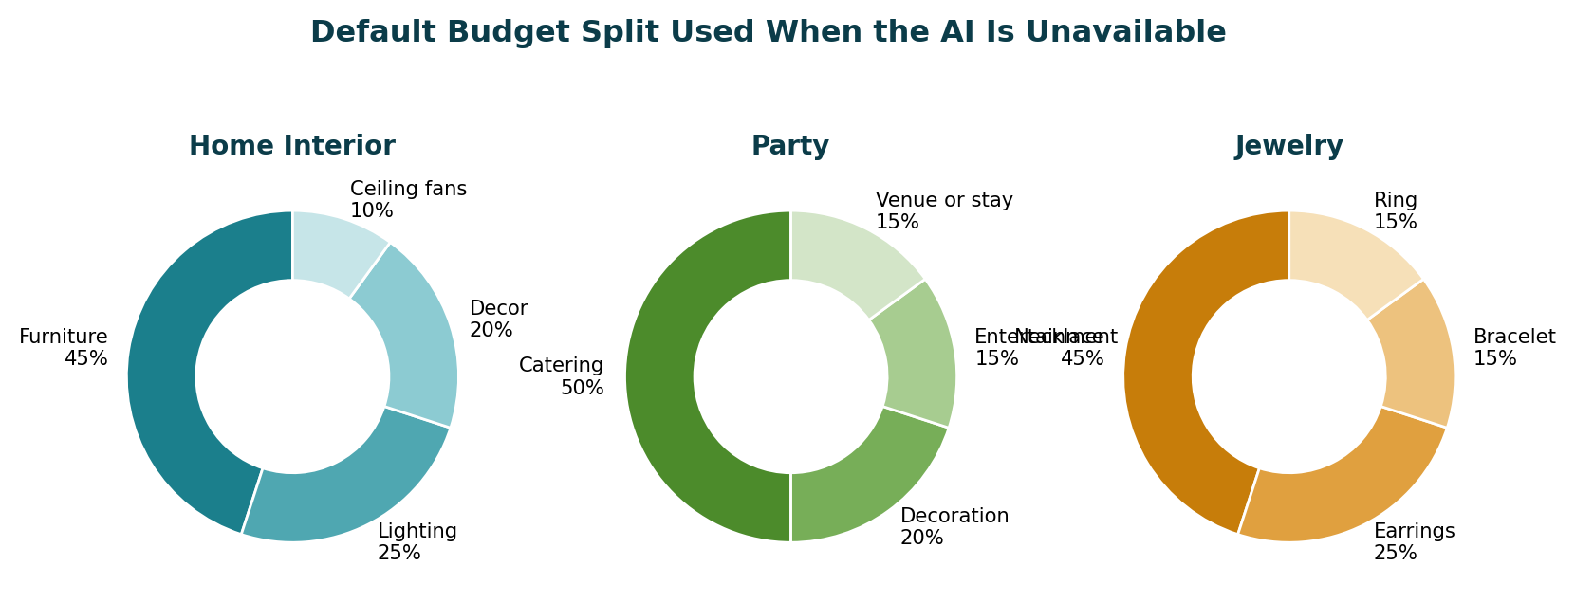
Figure 1: Default budget split per planner, used when the AI is unavailable

03 | System Design  How the pieces fit together

Technology stack
Layer | Technology | Why
Backend | Python, FastAPI, Uvicorn | Fast to write, clear routes, built-in validation
AI | Google Gemini (google-genai SDK) | Accepts text and images in one call
Database | SQLite | No server to install, one file
Frontend | HTML, CSS, Jinja2 templates | Server-rendered pages, simple to demo
Security | PyJWT, PBKDF2 hashing | HttpOnly token cookie, salted password hashes
Tools | VS Code, Git, GitHub | Development and submission

Architecture
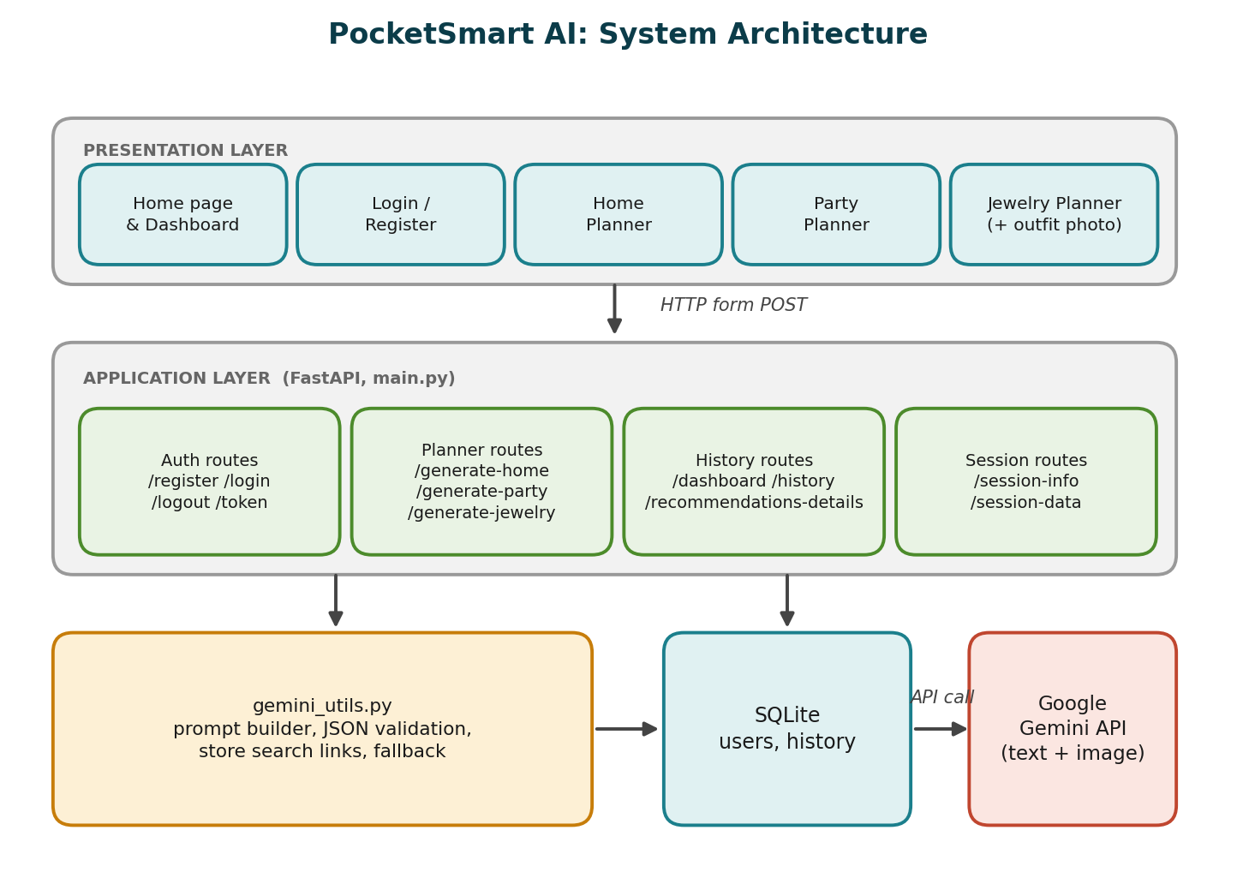
Figure 2: Presentation, application and data layers
Component | What it does
Frontend UI | Jinja2 pages for sign-in, the three planner forms, result cards and history.
FastAPI backend (main.py) | Authentication, sessions and the routes /generate-home, /generate-party and /generate-jewelry. Validates every input.
Gemini layer (gemini_utils.py) | Builds the prompt, calls Gemini with text and an optional image, validates the JSON, adds store links and totals the picks.
Fallback engine | Returns a default budget split when Gemini fails, so the page is never blank.
Database (SQLite) | users holds credentials. history holds every request and its result as JSON.

How one request flows
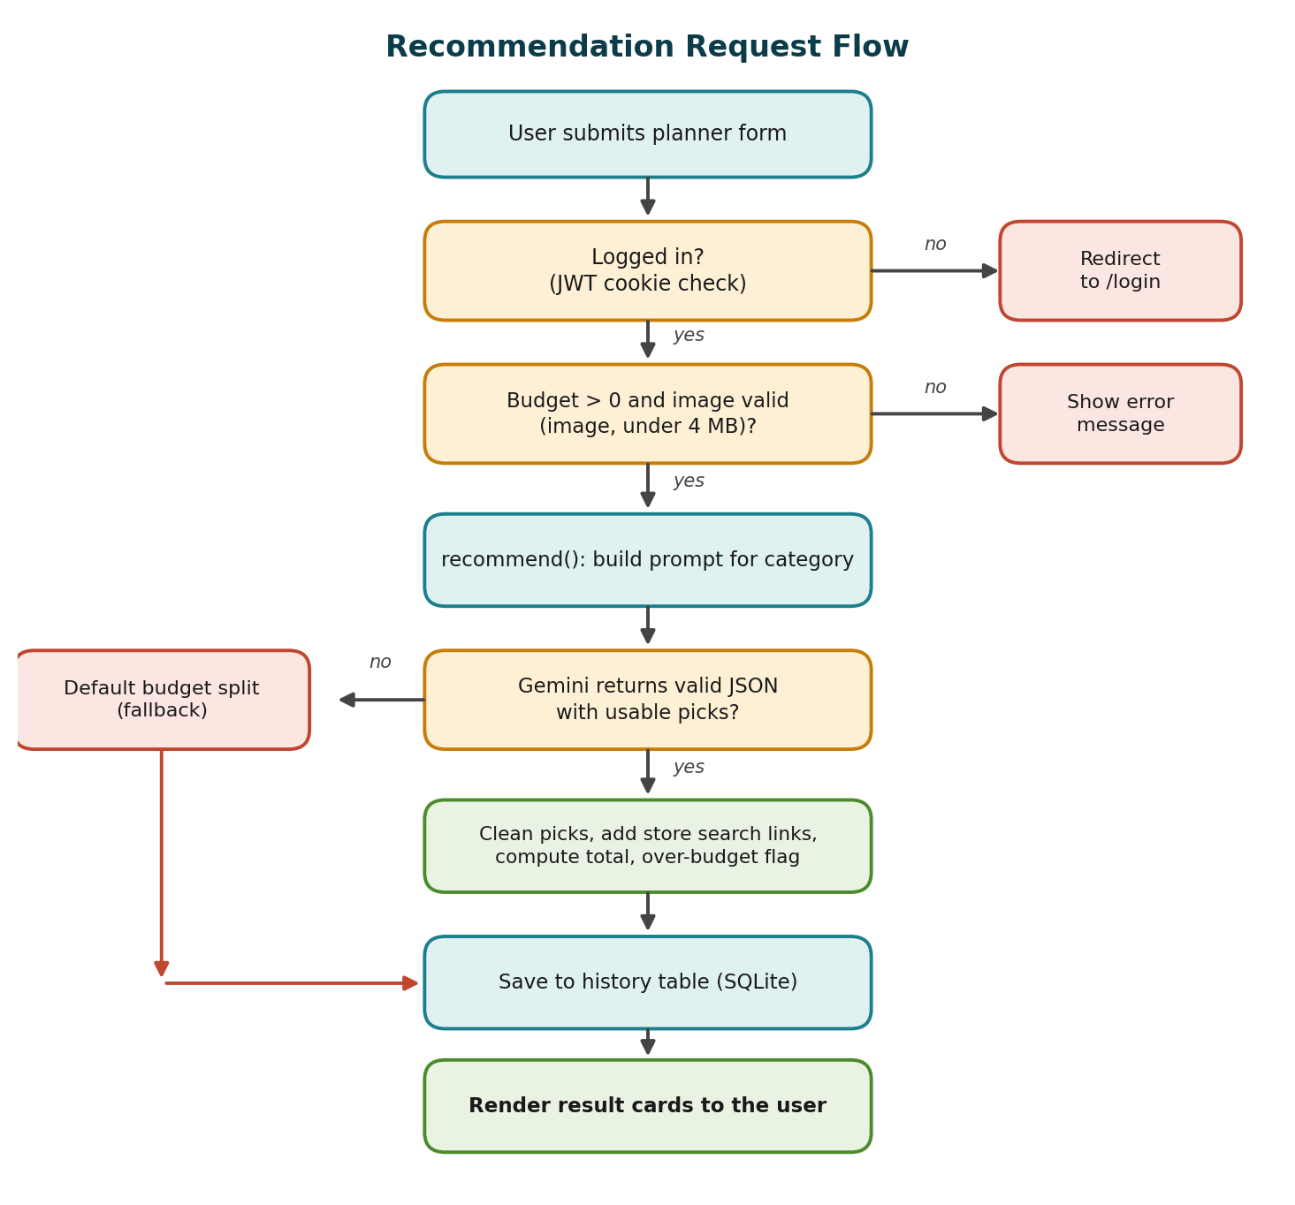
Figure 3: Decision flow for a recommendation request
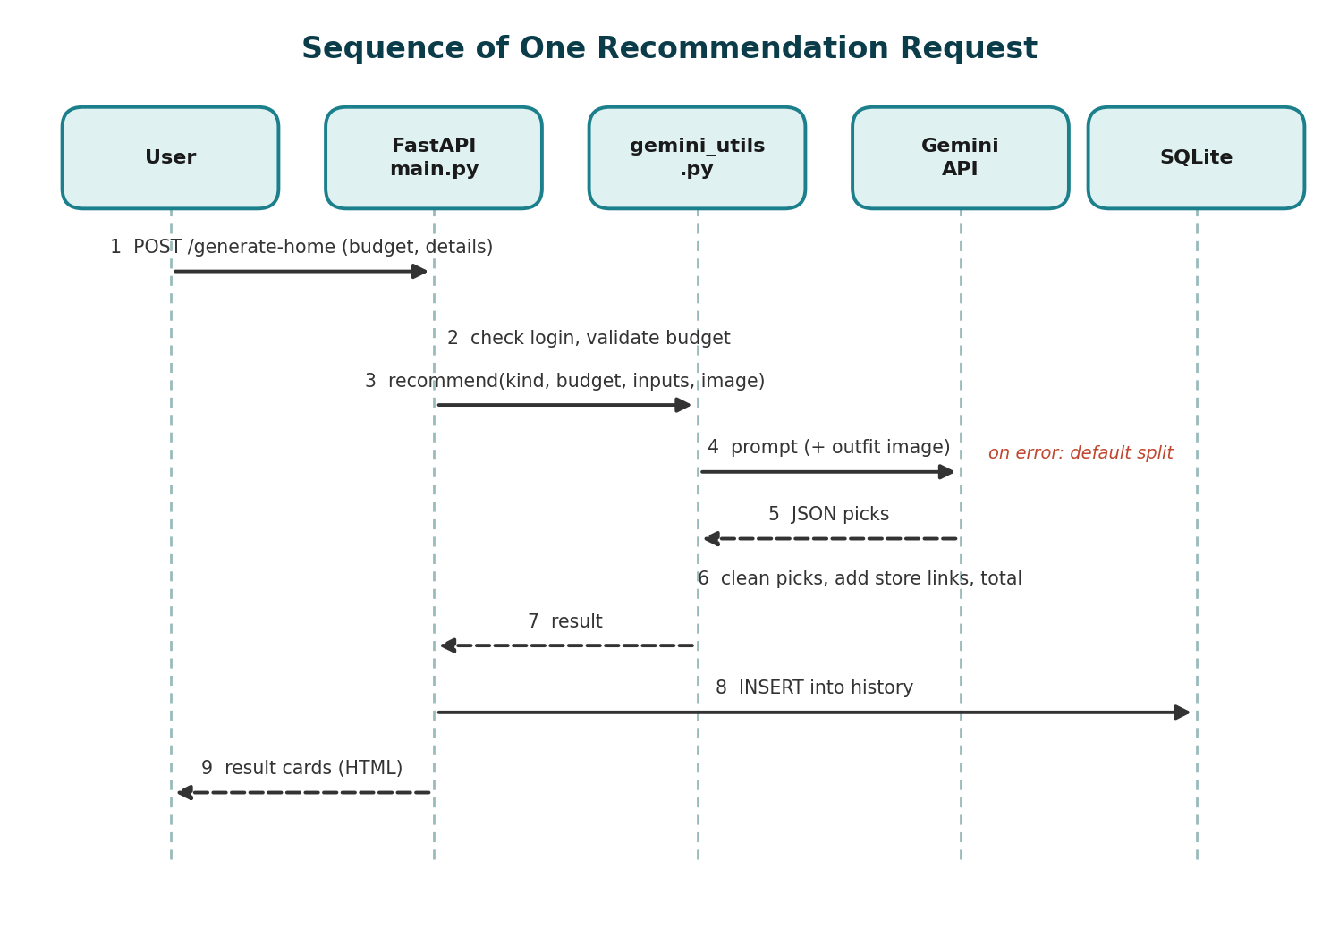
Figure 4: Which part talks to which, in order
Database
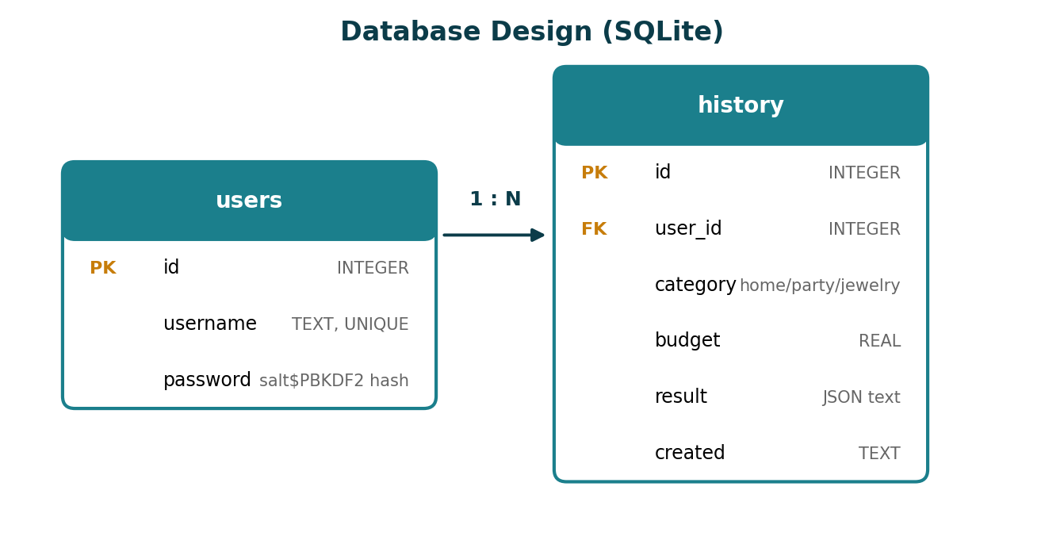
Figure 5: users and history, linked by user_id
User journey
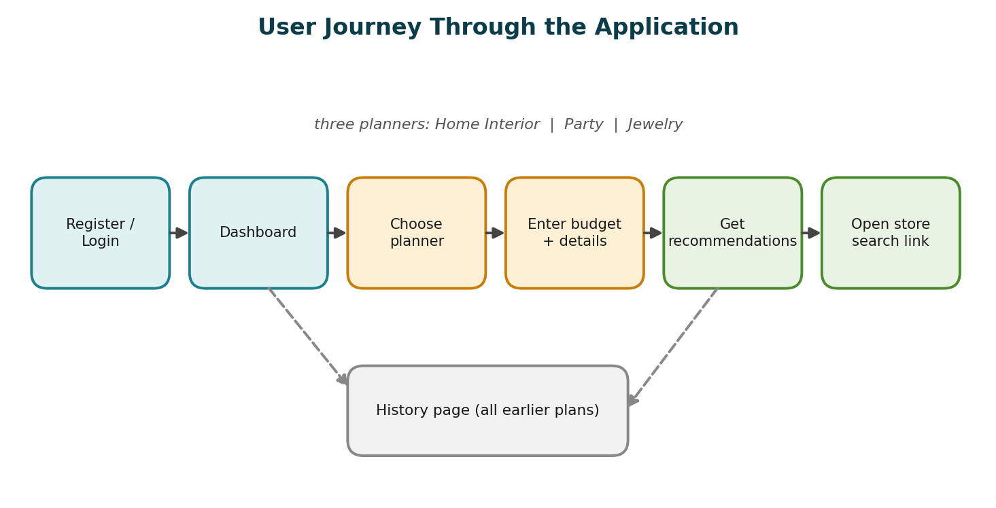
Figure 6: From sign-in to a store link
Routes
Route | Method | Purpose
/register, /login | GET, POST | Create an account and sign in
/logout | GET | End the session
/token | POST | Issue a JWT for API clients
/planner/{home, party, jewelry} | GET | Show a planner form (login required)
/generate-home, /generate-party, /generate-jewelry | POST | Validate, call Gemini, save and show the result
/dashboard, /history | GET | Recent and full history
/recommendations-details?id= | GET | One saved result as JSON
/session-info, /session-data | GET | Session details and usage summary

04 | Build Journey  Five milestones, each with the code that delivers it

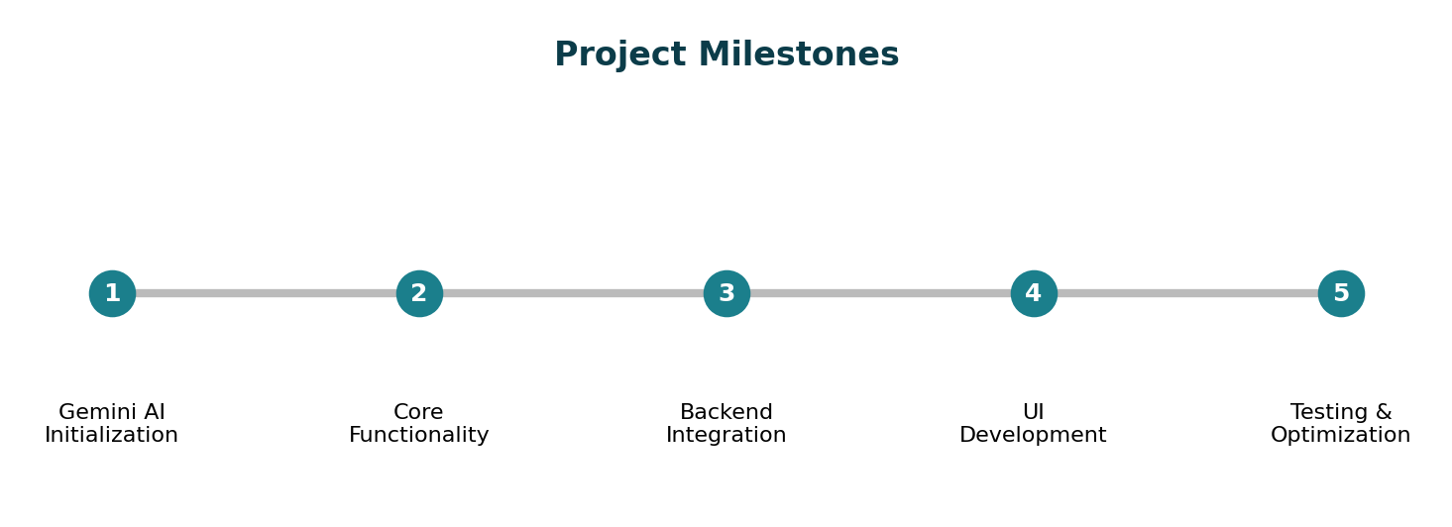
Figure 7: Milestones
Before you start
■ Python 3.10 or later and a code editor (VS Code)
■ A free Gemini API key from Google AI Studio (aistudio.google.com)
■ Git and a GitHub account for submission
Milestone 1 · Gemini AI initialization
The first goal is authenticated access to the Gemini API for both text and image prompts. Everything else depends on it.
▍1.1 Get an API key
Open Google AI Studio, accept the terms, choose Get API key, then Create API key, and copy it. Keep it private.
▍1.2 Configure the project
Save the key in a .env file. The app reads it at startup, and .gitignore keeps it out of GitHub.
.env
GEMINI_API_KEY=your-key-from-aistudio.google.com
GEMINI_MODEL=gemini-2.5-flash
SECRET_KEY=replace-with-a-long-random-string

TERMINAL
python -m venv .venv
.venv\Scripts\activate
pip install -r requirements.txt

▍1.3 Check that it works
PYTHON · TEXT AND IMAGE TEST
from google import genai
from google.genai import types
client = genai.Client(api_key="YOUR_KEY")

r = client.models.generate_content(model="gemini-2.5-flash",
contents="Suggest a sofa under 20000 INR")
print(r.text)

img = open("outfit.jpg", "rb").read()
r = client.models.generate_content(model="gemini-2.5-flash",
contents=["Suggest matching earrings",
types.Part.from_bytes(data=img, mime_type="image/jpeg")])
print(r.text)

Milestone 2 · Core functionality (gemini_utils.py)
All AI logic sits in one file. It defines the stores, builds a prompt for each category, calls Gemini, cleans the reply and supplies the fallback.
STORES AND SEARCH LINKS
MODEL = os.getenv("GEMINI_MODEL", "gemini-2.5-flash")
SHOPS = {"amazon": "https://www.amazon.in/s?k=", "flipkart": "https://www.flipkart.com/search?q=",
"ikea": "https://www.ikea.com/in/en/search/?q=", "swiggy": "https://www.swiggy.com/search?query=",
"zomato": "https://www.zomato.com/search?q=", "oyo": "https://www.oyorooms.com/search?location="}
PLATFORMS = {"home": ["Amazon", "Flipkart", "IKEA"], "party": ["Swiggy", "Zomato", "OYO", "Amazon"],
"jewelry": ["Amazon", "Flipkart"]}
HINT = {"home": "Cover every room and the requested quantities of lights, fans and dining tables; balance function, style and price.",
"party": "Split the budget across catering, decoration, entertainment and venue/stay for the event type and guest count; give cost per guest for catering.",
"jewelry": "Match the occasion and style. If an outfit image is attached, coordinate colours with it."}

PROMPT BUILDER
def _prompt(kind, budget, inputs):
ctx = "; ".join(f"{k}={v}" for k, v in inputs.items() if k != "budget" and v)
return (f"You are PocketSmart AI, a budget planner for shoppers in India. Category: {kind}. "
f"Total budget: INR {budget:.0f}. Details: {ctx or 'none'}. "
f"Use only these platforms: {', '.join(PLATFORMS[kind])}. {HINT[kind]} "
"Total of all picks must not exceed the budget. Prices are estimates in INR. Do not invent URLs. "
'Reply with JSON only: {"summary": "2 sentences", "picks": '
'[{"category": "", "name": "", "platform": "", "price": 0, "why": "one sentence"}]}')

CALLING GEMINI
def recommend(kind, budget, inputs, image=None):
try:
from google import genai
from google.genai import types
parts = [_prompt(kind, budget, inputs)]
if image:
parts.append(types.Part.from_bytes(data=image[0], mime_type=image[1]))
r = genai.Client(api_key=os.environ["GEMINI_API_KEY"]).models.generate_content(
model=MODEL, contents=parts,
config=types.GenerateContentConfig(response_mime_type="application/json", temperature=0.4))
text = r.text.strip().removeprefix("```json").removesuffix("```").strip()
return _clean(json.loads(text), kind, budget)
except Exception as e:
print("Gemini unavailable, using fallback:", e)
return fallback(kind, budget)

VALIDATION
def _clean(data, kind, budget):
picks = []
for p in data.get("picks", [])[:12]:
try:
price, name = float(p["price"]), str(p["name"]).strip()
except (KeyError, TypeError, ValueError):
continue
if name and price > 0:
picks.append(_pick(kind, str(p.get("category", kind)).strip(), name, str(p.get("platform", "")).strip(),
price, str(p.get("why", "")).strip()))
if not picks:
raise ValueError("no usable picks")
total = sum(p["price"] for p in picks)
return {"summary": str(data.get("summary", "")), "picks": picks, "total": total,
"over_budget": total > budget * 1.05, "fallback": False}

WHY VALIDATE
Model output is never trusted as is. Picks without a name or a positive price are dropped, the total is recomputed, and a warning is raised when it passes the budget by more than 5%.

FALLBACK
def fallback(kind, budget):
"""Default suggestions (used when Gemini fails or no API key is set)."""
picks = [_pick(kind, cat, f"{cat.lower()} {kind} essentials", PLATFORMS[kind][i % len(PLATFORMS[kind])],
round(budget * w), f"About {int(w * 100)}% of your budget.")
for i, (cat, w) in enumerate(WEIGHTS[kind].items())]
return {"summary": "Default budget split. Add a valid GEMINI_API_KEY for personalised picks.", "picks": picks,
"total": sum(p["price"] for p in picks), "over_budget": False, "fallback": True}

Milestone 3 · Backend integration (main.py)
main.py connects the browser to the AI layer. It handles accounts, guards the planner pages, stores history and exposes session routes.
▍3.1 Sign-in and security
PASSWORD HASH AND JWT
def hash_pw(p, salt=None):
salt = salt or secrets.token_hex(8)
return salt + "$" + hashlib.pbkdf2_hmac("sha256", p.encode(), salt.encode(), 100_000).hex()

def make_token(u):
return jwt.encode({"sub": u, "exp": dt.datetime.now(dt.timezone.utc) + dt.timedelta(hours=8)}, SECRET, algorithm="HS256")

/register
@app.post("/register")
async def register(request: Request):
f = await request.form()
u, p = str(f.get("username", "")).strip(), str(f.get("password", ""))
if len(u) < 3 or len(p) < 6:
return page(request, "auth.html", mode="register", error="Username needs 3+ characters and password 6+.")
if q("SELECT 1 FROM users WHERE username=?", (u,)):
return page(request, "auth.html", mode="register", error="That username is taken.")
q("INSERT INTO users(username,password) VALUES(?,?)", (u, hash_pw(p)))
return signed_in(u)

▍3.2 One handler for all three planners
The three generate routes share a single handler. It checks the budget and the image, calls the AI layer and saves the result.
HANDLER
async def handle(kind, request):
form = await request.form()
vals = {k: v.strip() for k, v in form.items() if isinstance(v, str)}
try:
budget = float(vals.get("budget", ""))
except ValueError:
budget = 0
if budget <= 0:
return planner(request, kind, vals, error="Enter a budget greater than 0.")
image, up = None, form.get("outfit_image")
if up is not None and not isinstance(up, str) and up.filename:
data = await up.read()
if len(data) > 4_000_000 or not (up.content_type or "").startswith("image/"):
return planner(request, kind, vals, error="Upload an image under 4 MB.")
image = (data, up.content_type)
result = ai.recommend(kind, budget, vals, image)
q("INSERT INTO history(user_id,category,budget,result,created) VALUES(?,?,?,?,?)",
(get_user(request)["id"], kind, budget, json.dumps(result), dt.datetime.now().strftime("%d %b %Y, %H:%M")))
return planner(request, kind, vals, result)

def make_endpoint(kind):

ROUTE FACTORY
def make_endpoint(kind):
async def endpoint(request: Request, user=Depends(current_user)):
return await handle(kind, request)
return endpoint

for _k in FORMS: # /generate-home, /generate-party, /generate-jewelry
app.add_api_route(f"/generate-{_k}", make_endpoint(_k), methods=["POST"], response_class=HTMLResponse)

▍3.3 Forms as configuration
FORM CONFIG
FORMS = {
"home": ("Home Interior Planner", [B, ("rooms", "Rooms (e.g. Living Room, Kitchen)", "text", []),
("lights", "Lights", "number", []), ("fans", "Ceiling fans", "number", []),
("dining_tables", "Dining tables", "number", []),
("style", "Style", "select", ["Modern", "Minimal", "Traditional", "Scandinavian"])]),
"party": ("Party Planner", [B, ("guests", "Guests", "number", []),
("event_type", "Event type", "select", ["Birthday", "Corporate", "Wedding", "Get-together"]),
("venue", "Venue details", "text", [])]),

▍3.4 CORS, session routes and startup
CORS
app.add_middleware(CORSMiddleware, allow_origins=os.getenv("CORS_ORIGINS", "http://127.0.0.1:8000,http://localhost:8000").split(","),
allow_credentials=True, allow_methods=["*"], allow_headers=["*"])
app.mount("/static", StaticFiles(directory="static"), name="static")
templates = Jinja2Templates(directory="templates")

SESSION ROUTES
@app.get("/session-info")
async def session_info(user=Depends(current_user)):
return {"user_id": user["id"], "username": user["username"], "logged_in": True}

@app.get("/session-data")
async def session_data(user=Depends(current_user)):
rows = rows_for(user, 100)
return {"total_queries": len(rows), "recent_categories": [r["category"] for r in rows[:5]]}

STARTUP
async def lifespan(app): # startup: create tables
q("CREATE TABLE IF NOT EXISTS users(id INTEGER PRIMARY KEY, username TEXT UNIQUE, password TEXT)")
q("CREATE TABLE IF NOT EXISTS history(id INTEGER PRIMARY KEY, user_id INTEGER, category TEXT, budget REAL, result TEXT, created TEXT)")
yield

if __name__ == "__main__":
import uvicorn
uvicorn.run("main:app", host="127.0.0.1", port=8000, reload=True)

Milestone 4 · User interface
Pages are rendered on the server with Jinja2 and share one base layout. The design is responsive, so it works on phones and desktops.
Template | Role
base.html | Shared layout with navigation and footer
index.html | Home page with a card for each planner
auth.html | Login and register, with clear error messages
planner.html | One form template used by all three planners, plus the results area
_cards.html | Recommendation cards: item, platform, price, reason, store link, total and warnings
history.html | Dashboard and full history

Each card shows the category, item name, platform, estimated price, a one-sentence reason and a store link. A summary and total sit above the cards. A warning appears when the plan is more than 5% over budget, and a notice appears when default picks were used.
RUN IT
From the 5. Project Development Phase folder run python main.py and open http://127.0.0.1:8000 in a browser.

[Add screenshots here: Home page, Register and Login, each planner result, History page]
Milestone 5 · Testing and optimization
Real budgets are run through every planner. Prompts, validation and the fallback are tuned from what the tests show. Details are in the next section.

05 | Testing & Quality  What was checked and how

Functional test cases
ID | Scenario | Input | Expected | Result
T1 | Register | New username (3+), password (6+) | Redirect to dashboard
T2 | Duplicate user | Existing username | "That username is taken."
T3 | Wrong password | Valid user, wrong password | Error message
T4 | Protected page | /history while logged out | Redirect to login
T5 | Home planner | 50000, Living Room + Kitchen, 4 lights, 2 fans | Cards with prices and links
T6 | Party planner | 30000, 40 guests, Birthday | Catering, decor, entertainment
T7 | Jewelry, text | 15000, Wedding, Traditional | Amazon / Flipkart picks
T8 | Jewelry, image | Same, with outfit photo | Picks match outfit colours
T9 | Zero budget | 0 | "Enter a budget greater than 0."
T10 | Bad upload | A .pdf as the photo | "Upload an image under 4 MB."
T11 | AI unavailable | Remove GEMINI_API_KEY | Default split, marked fallback
T12 | History | After T5 to T7 | All plans, newest first
T13 | Session routes | /session-info, /session-data | JSON with user and count

Fill the Result column after running each case and add screenshots below it.
Quality checks on AI output
■ The total of all picks stays within about 5% of the budget, otherwise a warning is shown.
■ Platforms match the category: Swiggy, Zomato and OYO for parties, IKEA for home items, Amazon and Flipkart for jewelry.
■ Every pick has a price, a reason and a working search link.
What was optimised
■ The prompt asks for JSON only and forbids invented URLs, so links are always built by the app.
■ Uploads are checked for type and size before they reach the model.
■ If Gemini fails for any reason, the default split from Figure 1 is shown and clearly marked.

06 | Limits & Next Steps

Current limits  ■ Prices are AI estimates, not live store prices.  ■ Links open a search page, not a specific product page.  ■ Quality depends on the Gemini model and on the detail the user enters. | Future scope  ■ Live price data through official partner APIs  ■ Favourites and side-by-side plan comparison  ■ More planners: travel, wardrobe, gifts  ■ Cloud deployment

07 | Conclusion

PocketSmart AI shows how a generative model, wrapped in validated forms and a dependable fallback, can give useful budget planning in a small web application. By combining Gemini's text and image understanding with FastAPI, SQLite and store search links, it helps a user plan a home, a party or a jewelry purchase within budget, and keeps every plan in a personal history.
Run the project
TERMINAL · WINDOWS
cd "5. Project Development Phase"
python -m venv .venv
.venv\Scripts\activate
pip install -r requirements.txt
copy .env.example .env # then add your Gemini API key
python main.py

Open http://127.0.0.1:8000, register, choose a planner and press Get recommendations.
Tools and references
FastAPI, Uvicorn, Jinja2, PyJWT, SQLite, Google Gemini API (google-genai), VS Code, Git and GitHub.

